Global Benefit Utility
The Global Benefit Utility routine is accessed by selecting the Global Benefit option from the Utilities drop-down menu. This routine will globally change benefit coverage information in the Benefit Code Master File. The option will change annual benefit information in the Benefit Code Maintenance File, as well as information in each individual employee benefit record where that provider and provider type combination is applicable (i.e., Blue Cross – Major Medical; Blue
Cross – Dental; etc.) AND where the coverage information is exactly the same.

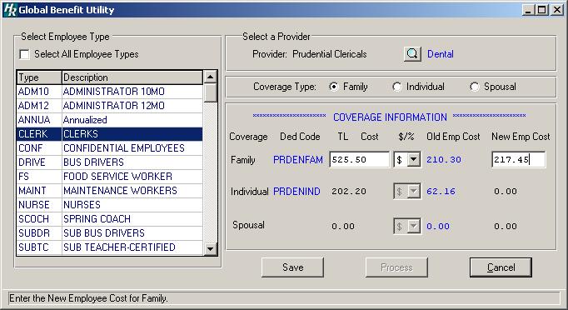

The Global Benefit Utility routine allows you to search the Payroll and Personnel files for employees who meet specified criteria and are eligible for a benefit coverage change. The system looks for employee records having a specific deduction code (if applicable) and coverage type and then calculates and updates “across-the-board” changes in benefit coverage based on the provider and benefit type selected.

To Perform a Global Benefit Coverage Change:
- Select an employee type from the browser by highlighting the appropriate code or check the Select All Employee Types box to change benefit coverage information for employees in all employee types.
- Press the Update button.
- Click the magnifying glass to display the Insurance Provider Lookup window. Highlight the desired provider and benefit type and press OK. The system returns the window being processed, having entered the selected provider in the appropriate field.
- Choose the coverage type to update. You may update Family, Individual, or Spousal coverage by clicking on the appropriate radio button. You can only process ONE coverage change at a time.
- The Coverage Information defaults to the deduction code, total cost, percentage/dollar indicator, and old employee cost defined in the Benefit Codes Maintenance File. Enter the new total annual coverage cost, percentage or flat dollar amount indicator (% or $), and new employee cost for the coverage type.
- Press the Save button.
- Press the Process button to record the change. Important: Remember to process one coverage change at a time.
- The system prompts you to confirm if you wish to proceed at this point.
Press Yes if you wish to continue the Global Benefit Utility update.
Press No if you do not wish to perform the Global Benefit Utility update.

The system automatically makes global changes based on those employees who meet the specified criteria. The Employee Benefits window in the HUMAN RESOURCES Employee Information Maintenance Personal folder reflects the new Employee Portion and Total Cost, as well as the adjusted Employer Portion. The revised Total Cost, Employee Cost, and Employer Cost information is also reflected for the benefit coverage in the HUMAN RESOURCES Benefit Codes Maintenance routine.

